Jonah Byther

Purpose:

The purpose of this lab is to be able to ping across multiple routers using OSPFv3, and to use different areas across the routers and still be able to ping

Background:

IPv6 is better at making sure internet traffic gets to the correct destination without being intercepted. It also handles packets more efficiently. We also are making the switch over from IPv4 to IPv6 because we are running out of IPv4 addresses. To set up OSPFv3, we need to make sure that each router has a different router Id, so that the first one is 1.1.1.1, and then the second one is 2.2.2.2, and so on. We also set up 3 different areas of OSPFv3 between the routers

Lab Summary:

We set up 5 routers and 5 PCs and connect each PC to a different router, and each router to a different router, and we put IPv6 address on each connect interface as well as the PCs.

Lab Commands:

1. Ipv6 address
2. This command lets us implement an IPv6 address into the router
3. Ipv6 router ospf 1
4. This puts us into the ipv6 router OSPF
5. Router-id
6. This command helps us put in the router ids for each router
7. Ipv6 route
8. This helps us put in each ipv6 route we need to put in in order to be able to ping

Network Diagram:

Next page,

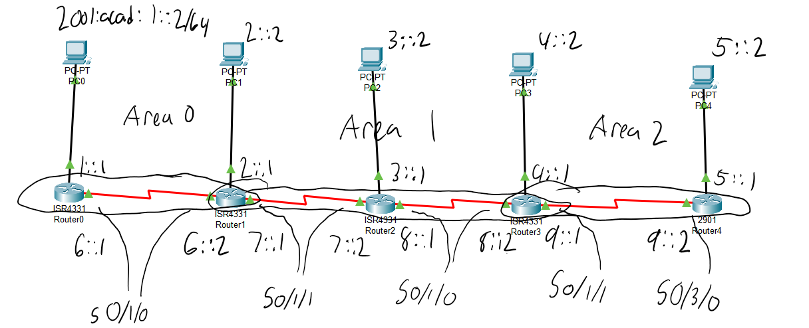Configurations:

Show run on router 0:

ipv6 unicast-routing

no ipv6 cef

spanning-tree mode pvst

interface GigabitEthernet0/0/0

no ip address

duplex auto

speed auto

ipv6 address 2001:ACAD:1::1/64

interface GigabitEthernet0/0/1

no ip address

duplex auto

speed auto

shutdown

interface GigabitEthernet0/0/2

no ip address

duplex auto

speed auto

shutdown

interface Serial0/1/0

no ip address

ipv6 address 2001:ACAD:6::1/64

ipv6 ospf 1 area 0

interface Serial0/1/1

no ip address

clock rate 2000000

shutdown

interface Vlan1

no ip address

shutdown

router ospf 1

log-adjacency-changes

ipv6 router ospf 1

router-id 1.1.1.1

log-adjacency-changes

ip classless

ip flow-export version 9

ipv6 route 2001:ACAD:2::/64 Serial0/1/0

ipv6 route 2001:ACAD:3::/64 Serial0/1/0

ipv6 route 2001:ACAD:4::/64 Serial0/1/0

ipv6 route 2001:ACAD:5::/64 Serial0/1/0

line con 0

line aux 0

line vty 0 4

login

end

Show ipv6 route on router 0:

IPv6 Routing Table - 11 entries

Codes: C - Connected, L - Local, S - Static, R - RIP, B - BGP

U - Per-user Static route, M - MIPv6

I1 - ISIS L1, I2 - ISIS L2, IA - ISIS interarea, IS - ISIS summary

O - OSPF intra, OI - OSPF inter, OE1 - OSPF ext 1, OE2 - OSPF ext 2

ON1 - OSPF NSSA ext 1, ON2 - OSPF NSSA ext 2

D - EIGRP, EX - EIGRP external

C 2001:ACAD:1::/64 [0/0]

via GigabitEthernet0/0/0, directly connected

L 2001:ACAD:1::1/128 [0/0]

via GigabitEthernet0/0/0, receive

S 2001:ACAD:2::/64 [1/0]

via Serial0/1/0, directly connected

S 2001:ACAD:3::/64 [1/0]

via Serial0/1/0, directly connected

S 2001:ACAD:4::/64 [1/0]

via Serial0/1/0, directly connected

S 2001:ACAD:5::/64 [1/0]

via Serial0/1/0, directly connected

C 2001:ACAD:6::/64 [0/0]

via Serial0/1/0, directly connected

L 2001:ACAD:6::1/128 [0/0]

via Serial0/1/0, receive

OI 2001:ACAD:7::/64 [110/128]

via FE80::2E0:F9FF:FED0:6401, Serial0/1/0

OI 2001:ACAD:8::/64 [110/192]

via FE80::2E0:F9FF:FED0:6401, Serial0/1/0

L FF00::/8 [0/0]

via Null0, receive

Show ipv6 ospf neighbor on Router 1:

Neighbor ID Pri State Dead Time Interface ID Interface

1.1.1.1 0 FULL/ - 00:00:38 4 Serial0/1/0

3.3.3.3 0 FULL/ - 00:00:38 5 Serial0/1/1

Problems:

A problem I had was not setting the routers and interfaces to the right area for that specific router. I accidentally set some of the interfaces to the wrong areas, so I had the serial port on Router 0 to area 1 at first. Also, when I first started working on the lab, I completely forgot what an IPv6 address was supposed to look like, but I eventually figured it out.

Conclusion:

In conclusion, every PC was able to ping each other and routers have set IDs and OSPFv3 is implemented into the network.